**Chapter 1**

**INTRODUCTION**

**Project Context**

Technology is a very vital factor in our generation today. With each passing day a new software or gadget is being brought into the market that serves to improve our lives in one way or another and make it much easier and also to advance an already existing software or gadget. However, it is important to note that despite the fact that technology plays a big role in making our lives easier. Occasionally a new technology appears which promises to change our lives for the better. It either improves our performance by working more simply and at a faster rate, or it creates possibilities and options that did not previously exist.

On the development of realty in the country, one of the developing realty agents was established by Mr. Mario Magtibay who eventually became a Sales Agent in year 2010. Three years after, Mr. Mario Magtibay became a Real Estate Broker and as a result, he got an idea to build their own Real Estate business which became the M.A. Magtibay Realty, and now handling an own business with the help of his children and was surely run till the next family legacy. The business of Real Estate is the profession of buying, selling, or renting land, buildings, or housing. You can make a lot of money by starting a real estate business, whether as a real estate agent or as an investor.

With the increase in the number of transactions at a branch, the total workload of the staff has become so big that the company is employing more staff to handle the ever-increasing amount of paper work. There is also a legal requirement to produce detailed monthly, quarterly and annual reports. Management also needs summarized statistical data in order to have access to all the data pertinent to a decision. Inferential statistics always act as a tool to have a look at all the data of an organization in a precise, summarized form. The proponents found out some issues in running a real estate business. As they go on interviewing the representatives mentioned that they are using hand-operated encoding day by day to update those data they gathered from the agents. Most of the Sales Agent used a group chat to forward the information to manager or Sales Broker. But other than that, there also some difficulties in monitoring, utilizing and maintaining the data of a business and also they struggle to maintain all the information from all over two hundred (200) agents around Batangas per day. The advent of computers can ease out this hassle. With the organized data storage system.

The company needs a system that will help monitor all transactions in a fast and easy way. Therefore, the researchers decided to create a system that will enable the company attain this objective and will help the company to make work easier and more efficient using the system. This system will automate processes involved in monitoring and managing the data.

**Purpose and Description**

The purpose of this study is to provide an easier way of managing records and accounts that will help owner to keep tracks of all the transaction happening every day. The agents will have a fast and easy way of interacting with the client that will serve as an answer to the mission of the Real Estate. In this study

Moreover, the project will help the projects objectives and serve as a more reliable tools in terms of managing all data, agents information and generating and printing sales report for admin and receipt for agents. This study focus also in monitoring the daily status of the clients and agents. It also include the maintenance of data and sales. The beneficiaries of this project will be M.A. Magtibay Realty.

**Objectives of the Study**

The main purpose of this study is to develop a records management system for M.A. Magtibay Realty to simplify the way of handling accounts and records of its clients.

Specifically, it aims to achieve the following objectives:

1. To develop website for M.A. Magtibay Realty that includes the following:

1.1 Promotional Page

1.2 Administrator Panel

1.3 Agent and Manager Portal

2. Creating database of the following:

* 1. Sales and Records of M.A Magtibay Realty
  2. Developer Properties and Information
  3. Prospect buyers

3. Provide a module that computes the shares and commissions.

**Scope and Limitations**

The system to be developed is an online real estate management through which individual or client of the realty can maintain their property document keeping and managing property, registration and also access its information and manage all the adding, updating, deleting some of its tasks. The Admin user can inform their agents for regarding to property and update the information regarding property and cancellation of property or changing buyer choice. The system is very useful for the companies or builders that can post and edit the information of their properties and their personal information and admin can monitor records of all of them.

**Definition of Terms**

To understand and clarify the terms used in the study, the following are hereby defined:

**REAL ESTATE.** Is the property, land, buildings, above the land and underground right below lands.

**REAL ESTATE DEVELOPER.** A person who buys and develops houses, buildings, and land in order to sell them and make a profit from them

**ESTATE.**An Estate can be seen as a property to which a person is lawfully entitled. In traditional law, it refers to property in land; a person’s Estate consists of the interest or rights that the person held in land.

**RECORDS.** The context of record in this study refers to the organized information of from data from the database. In the proposed system, records will define as records of the client, agent and sales.

**MANAGEMENT.** Management is the function that coordinates the efforts of people to accomplish goals and [objectives](https://en.wikipedia.org/wiki/Goal) by using available resources efficiently and effectively. It includes [planning](https://en.wikipedia.org/wiki/Planning), [organizing](https://en.wikipedia.org/wiki/Organizing_%28management%29), [staffing](https://en.wikipedia.org/wiki/Staffing), [leading](https://en.wikipedia.org/wiki/Leadership) or directing, and [controlling](https://en.wikipedia.org/wiki/Control_%28management%29) an organization or a system to accomplish a goal. In the proposed system, management will serve as managing all the data presented in the system.

**REPORT.** It is any informational work made with the specific intention of relaying information in widely presentable form (Liz Walter, 2015). In the study, it includes school report, grade report, transcript and more. In the proposed system, records will define as report of the client, agent and daily, monthly and yearly sales.

**BROKER.** Brokers work within a wide variety of private industries, and typically work within a company’s sales department. They work below sales managers and supervisors, and it’s often seen as a starting position for people interested in sales.

**CHAPTER 2**

**REVIEW OF RELATED SYSTEMS**

This chapter primarily presents the different researches and other literatures from both foreign and local researchers, which have significant bearings on the variables included in the research. It focuses on several aspects that will help in the development of this study. The study is generally concentrating on the feasibility of creating a Real Estate Management of MA Magtibay Realty.

**Technical Background**

This shows the technologies and technical tools to be used in the development of the system.

The researchers will be using Hypertext Markup Language (HTML) and CSS for the design and layout for the system that will be develop the whole design of M.A Magtibay Realty System. They components will use this because they have the broad knowledge on these two, since these are the language for web development. Since, the researchers will be making a system, HTML will be considered as the skeleton of the system because it holds the information and function within the website. CSS will be the visual style it helps for styling colors, layout, background and fonts. It also a great help because it minimizes the codes and make them more understandable. For storing and retrieving of data, the researcher will use MySQL, it is also use in a website because it is very fast, reliable, and easy to use. MySQL has one major advantage, since it is free. If a web application requires more than database, requires load balancing or shading, it is easy to set up maybe instances of the database requiring only the hardware costs, as opposed to commercial databases that would require a single license for each instance. MySQL become an optional to be used because of the large data and information that being stored in the database. MySQL became an option to be used because of the large data and information that is being stored in the database. MYSQL affordability and being free are the things that made the researchers choose MYSQL as the database for the system. PhpMyAdmin will be use by the researchers to manage the databases easily. It offers a more user-friendly interface for adding, removing, modifying and deleting databases. The developers easily monitored and assured that the data entered through form with the use of PHP integrates and connects well to its respective databases.

**Related Systems**

The following are local and foreign studies that contribute a lot on the gathering information about the develop system. Relevant ideas on the different sources formed the bases in the conceptualization and development of the system.

[According to study of Jojo Balagosa](http://jinisyssoftware.com/author/jbalagosa/" \t "_blank) (2017) entitled Real Estate Management System in the Philippines. Jinisys started as a provider of PMS for the hospitality industry. Since RE is related to hospitality in some aspects, the company introduced products that deliver solutions for RE and condominium properties aimed to increase efficiency and productivity. Jinsys Software offers four software that handles property administration, the first is [RE PMS](http://jinisyssoftware.com/real-estate-property-management-software-system/), the second is [condominium](http://jinisyssoftware.com/condominium-property-management-system-philippines/)PMS, third is cemetery or entombment management software, and the fourth is a parking program. These systems greatly improve the productivity and efficiency of businesses by providing key features and functions needed in REMS such as amortization, commission payables, and lot status through desktop and web application. Jinisys’ Provides software’s for many different types of business, which includes Hospitality, Communication, Point of sale, Healthcare management software, Inventory software, property management software, Tailor-made, Mobile applications and software application products. From the abundant product portfolio that Jinisys’ has we will be concentrating mainly on PMS which becomes key for organization which does proper administration. Their REM module helps companies to keep track of properties, status of their occupancy and value of the them. This technology also provides a versatile tool to the company which helps them in easy handling of payments, sales and prices. It also tracks the commission payables for agents and receivables and with it manages the company amortizations.

In Konstantinos Manikas (2016) study entitled Records Management and Electronic Records Management this Master thesis focuses on the concept of Records Management (RM) and Electronic Records Management (ERM) and how the adoption of an Electronic Document Records Management System (EDRMS) affects a business setting. The research focuses on the factors of perceived efficiency and on the costs that exist in a company. More specifically, this Master thesis is a qualitative exploratory case study which's aim is to examine and present the experiences and the attitudes of 4 individuals who are working in companies that possess an EDRMS. In order to acquire this deeper understanding, the data collection methods that were used were the in person semi structured interviews and the observation. During the research was examined how the perceived efficiency and the costs in a company are affected by a proper RM/ERM program. The analysis of the collected data shown that the specific individuals in the specific firms are benefited by the EDRMS and that their work is improved.

# [Zhou Yao](https://ieeexplore.ieee.org/search/searchresult.jsp?searchWithin=%22Authors%22:.QT.Zhou%20Yao.QT.&newsearch=true), [He Guohui](https://ieeexplore.ieee.org/search/searchresult.jsp?searchWithin=%22Authors%22:.QT.He%20Guohui.QT.&newsearch=true) (2018) this thesis entitled The research of multidimensional analysis based on multi-source heterogeneous real estate data is through multidimensional analysis of real estate transaction data provided by the government department and some relevant information crawled from the Internet, real estate market's changing rules and trends can be found from different aspects. It is convenient for people to understand real estate's development better. The traditional relational storage mode and analysis method are difficult to be used in the data from different sources and structures. Therefore, as to the problem about storage and multidimensional analysis of unstructured data, we put forward a method using MongoDB for heterogeneous data storage and Pentaho - an open source business intelligence suite - for multidimensional analysis in this paper. The research and application show that Pentaho can solve the multidimensional problems of non-relational data better, and it is very convenient to make data visualization.

In addition, with the study of Benjamin Richard Lahue (2014) entitled Management Information Systems often referred to as MIS is the people-oriented use of computers in business. MIS is both a field of study and a career path. It combines the foundations of computing, analysis, and business in to one field of study. MIS is a major that is growing in popularity; however, it is still unknown to many undergraduates. This thesis includes both research and creative aspects. The information gathered by research was used to generate the requirements for an information portal relating to the MIS program at the University of Northern Iowa (UNI). A portal is a one stop shop for information, resources, and tools relating to a specific topic, in this case, MIS. The primary purpose of the information portal is to be a resource of vital information relating to the MIS program at UNI. This portal is directed towards three primary audiences: prospective students, current students, and alumni. The portal provides information relating to what MIS is, why to choose MIS as a major, what MIS majors can do, and what the MIS program at UNI entails. In addition, the portal provides current undergraduates with key resources for success such as potential employers, what alumni have done, and job opportunities. An information portal for the MIS program at the College of Business Administration at UNI (also referred to as UNIBusiness) does already exist; however, there are some issues with the current portal. The existing portal has not been maintained in some time and as such, it is not always the best source of information. In addition, technology has changed greatly in the just the past few years which has rendered the existing portal outdated. Currently the existing portal is not a centralized information source; information relating to MIS is currently scatted across the UNIBusiness site. Finally, the desires and expectations of students have changed greatly over the past few years. Since the portal is geared primarily towards students, it must meet their desires and expectations. It is a combination of these factors that prompted this thesis, the creation of an information portal for the MIS program at UNI.

According to Karen Cleary Aldrman (2012) thesis entitled Property Management Systems in this document address requirements for property management systems. Agencies must use these functional requirements in planning their property management systems improvement projects, and may develop additional technical and functional systems requirements as needed to support unique mission responsibilities. Agencies must also develop strategies for interfacing or integrating property management systems with their Core Financial System and other applicable systems. This document acknowledges that property management system functionality does not necessarily reside in a single software application or functional system. In fact, property information may reside in or may be calculated in a number of applications or systems. The property management systems described in this document may be comprised of all these applications and/or systems, their interfaces, and the processes required to manage property.

In the study conduct by Wana Godwill (2016) entitled Real Estate Management System a documentation of the computerized approach to improve record keeping and management decision-making practices of a real estate agency by using statistical summary data analysis and inference. The system was designed to improve on the efficiency of such a company’s management through easy and quick access to all records. The computer package is named REMIS. The REMIS system has modules that provide tools to analyze data and make inferences about the data for management decision-making.

In addition, Rohit Kumar Gupta (2011) entitled Mobile Real Estate Agent for Android this application is a one-stop destination for everything you want to know about a property. One can search a property based on MLS number, one has the option to search a property based on its location. Users can also use detailed search options where they can feed in the desired number of bedrooms, area etc. and get a list of matching properties. A user can find all the details about the property. One can also search properties under a specific Real Estate Agent using our Agent Directory. Apart from all these features, the user has been provided the ability to get directions to that property. Mortgage Calculator is another one of the interesting features that comes embedded into this application.

Xuexiang Li, Fulin Bian, Yongge Shi (2012) study entitled System Integration of Digital Real Estate-Management Based on Service is an architecture design real estate management based on service is provided based on the analysis current situation of estate-management in our country to solve the problems about system integrations between sub systems of estate-management. The policy of integration is the key point, which includes the interactive between mixed demission of house spatial data surveying and mapping, the interactive between house spatial data surveying and mapping and house property data management, the interactive between public application and special application. An example finally is specifically developed based on design. The study of system integration of digital real-estate management, especially taking the public application into the system design and multi demission of house spatial data management shows a revolutionary significance to the information of real estate management in our country at present.

In study of Anna Rozenblit (2012) entitled Methods of Product and Service Promotion in Social Network Websites Demonstrated. The purpose of the current study was to develop a model of promoting goods and services in social network websites with an example of a website VK, the most popular social network in Russia and other former Soviet republics. In the first chapter, to begin with were described the main characteristics of Internet services and their usage for online product and service promotion. Next were analyzed various factors that determine the effectiveness of online communications. The advertising campaign goals were divided into two groups: economical and communicative. From that, the effectiveness of advertising was also divided into two components: communicative and economical effectiveness. To access the effectiveness of online advertising it was proposed to utilize the comprehensive system of evaluating the effectiveness at the stage when Internet consumers engage with advertising information. This joint system integrated the so-called “AIDA concept”, which assumes four steps in the consumer purchase-decision process: attention, interest, desire and action; and major web analytics that measure and analyze the effectiveness of online marketing activities. Another important step in product and service promotion is to select the right supplier of resources, in our case, advertising space and time. To develop the appropriate techniques for selecting and evaluating suppliers of online advertising resources was used an analogy with the procurement logistics’ supplier selection and evaluation process. In the second chapter was given the concept of social networks. To identify the aspects of promoting goods and services in social networks was provided an example of promoting goods of an online store Ochkoff.net in the widely used website VK. The advertising campaign resulted in profits and, consequently, it was concluded that with the right choice of a social network as supplier of ad space and time it is possible to promote products and services successfully and cost-effectively.

The thesis entitled Real Property Processes made by Marina Vaskovich (2012). This work aims at advancing the scientific understanding of the real property processes stimulating the Belarusian property market specifically in order to promote its development. For a property market to operate efficiently, real properties ought to be able to be smoothly created and securely transferred with the aid of real property processes. These processes, after being implemented, generate transaction costs for a society, while the ways by which they are arranged can increase or decrease such costs. This research applies institutions as a theoretical ground with the transaction costs theory as a core concept for the examination of the selected property processes, resulting in a body of new knowledge on the relations between institutions, property processes and transaction costs. This study specifically investigates property formation and purchase processes in Slovenia, Sweden and Belarus through an ontological modelling supported by their descriptions. It additionally explores the content of property rights along with the existing real property legislation of the selected countries, as such are recognized as components influencing real property processes. Consequently, general descriptions of the land tenure systems of these three countries and a classification of fundamental property rights are presented. The examined property processes are compared in order to identify differences and thereby generally enrich the theoretical knowledge in the land administration domain. This comparison is based on the transaction costs generated by the specific real property processes and relatively estimated by this research with a focus on the stakeholders involved, their functions and interactions.

**Chapter 3**

**DESIGN AND METHODOLOGY**

This chapter describes the discussion on the conceptual design and system architecture of the developed system. The data were evaluated and analyzed to provide good result. The methodology that was used in developing the system is discussed in this chapter.

**Requirements Analysis**

Requirements Analysis contains a summary of the features of the system that helps the beneficiary. This information was used to help the reader understand why the requirement is needed.

In the beginning of the study, the researchers studied the current situation of the manual process being implemented in MA Magtibay Realty.

**System Features**

1. The system that will be develop can provide the guarantee that all the information and data can easily access by the admin.
2. The administrator can see and manage all the member’s accounts of agents.
3. The search / gallery option in the system provide the all the images regarding the current properties and upcoming properties.
4. This system provides the login facilities to the user, so that security is maintaining by the admin.
5. The portal that will shows the information about sales and statuses of an agents.

**Functional Requirements**

In the backbone design of the developed system, the developers considered the requirements given by the client to suit the needs of MA Magtibay Realty. It dealt with the developed system provided for the users.

**Functional Requirements**

1. **Authentication**

R1. The agents shall be able to access the login form.

R2. The admin and agents shall be able to enter the username and password.

R3. The database shall be able to validate username and password.

1. **Security Requirement**

R1. System can use secured database.

R2. Proper user authentication shall be provided.

1. **Report**

R1. The admin shall be able to generate an overall report of sales.

**Non- Functional Requirements**

The developers determined the non-functional requirements of the system that contributed to developing the system based on the user requirements.

**Reliability** The system handled the expected error to ensure accuracy and the correct output information.

**Usability** The system should be easy to use.

**Security** The system will verify all the access information before granting access to a user.

**Maintainability** The system must be easy to maintain when an error or bug arises.

**Accessibility** The system can allow the administrator to create accounts.

**Development Model**

Figure 1 shows the agile model which contains analysis, design, coding, testing and implementation phase. The Agile SDLC model is an iterative and incremental process combined process models that focuses on process adaptability and customer satisfaction by rapid delivery of working software product. The developers decided to use agile model in developing the application, because it has the advantage of flexibility and the allowance of requirements change. It was also used because it will be easy for the developers to make changes that will or might occur in the future.

**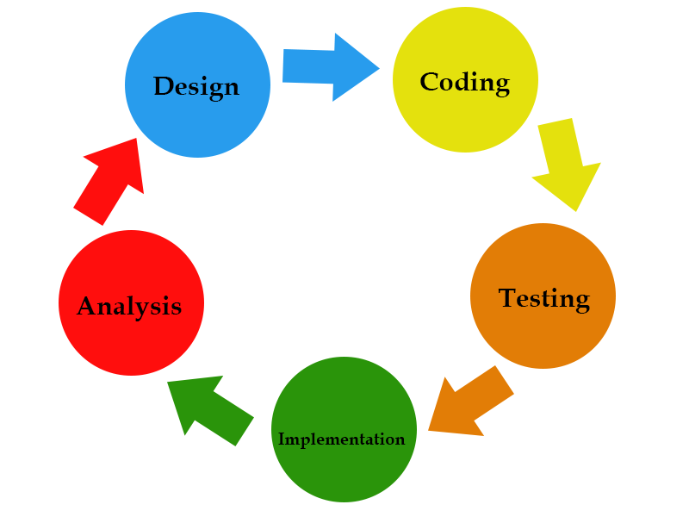**

**Figure 1. Agile Development Method**

**Analysis of the Proposed System**

**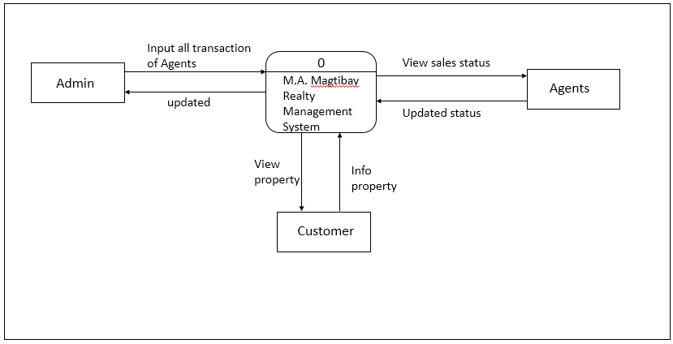** The purpose of the Real Estate Management is to help to keep their details and manage the sales. The Real Estate Management System that is designed for the individual investor or small business owner of several rental houses, apartments. The software covers all the functionally related to tenancy management, sales and marketing, managing all the information related to their payments, lots, legal document, inspections, reports etc.

**Figure 3. Context Diagram of the Proposed System**

**Data Flow Diagram**

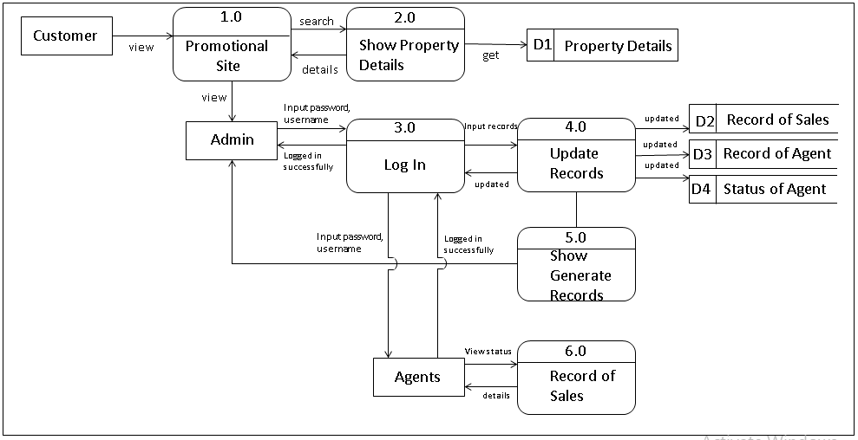Figure 4 shows the whole process of the system. Admin has the access to the overall function of the system to be develop. The system to be develop performs the work easy and in a timely manner.

**M.A Magtibay**

**Figure 4. Data Flow Diagram of the Proposed System**

**Architectural Literature**

By analyzing the system, the developers were aided to come up with suitable system. The developers thought of the appropriate use interface for the system. The design of the graphical user interface of the system was made pleasing to eyes of the user and easy to navigate.

**Link Architecture**

The researchers used a link architecture to show the functionality of each user in the system and was used as a basis in constructing the flow of the system.

**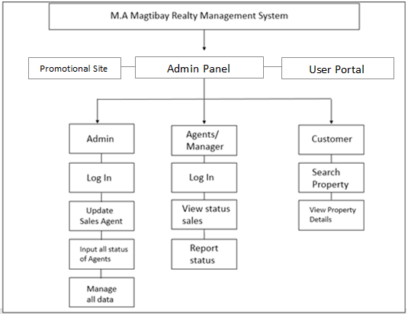**

**Figure 5. Link Architecture of the System**

**Software Development Tools**

The software development tools that the developers used are Hyper Text Markup Language, CSS, MySQL, JavaScript and PHP.

The proponents used JavaScript in developing the developed system for M.A. Magtibay Realty. JavaScript allows the researchers to do more less code because some of the codes in JavaScript can also be used into any other pages. Less code means less maintenance time and less coding time.

MySQL used as the database storage for the data information. Through the help of PHP, it can secure the access of database and other information regarding the system.

**Use Case**

Figure 5 shows the use case model which describes every role of the user of the system. The Admin is authorized to manage the system. The Admin can update those records for Sales Agent, Manager and Sales. The Admin is the one who can input sales to the Agents. The Customer is the one who can view the site.

**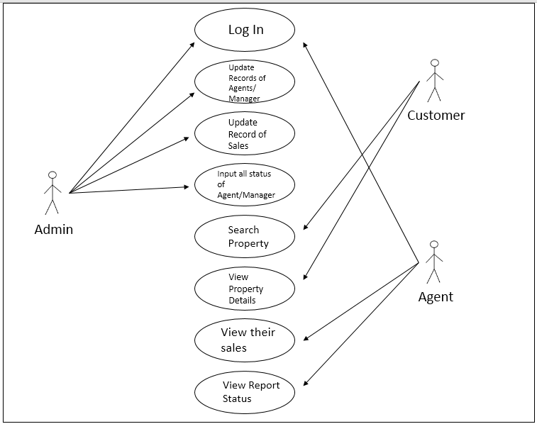**

**Figure 6. Use Case Model**

**Graphic User Interface**

Show the graphic design interface of the website of M.A. Magtibay Realty. In this interface show the land properties and promotions available.

**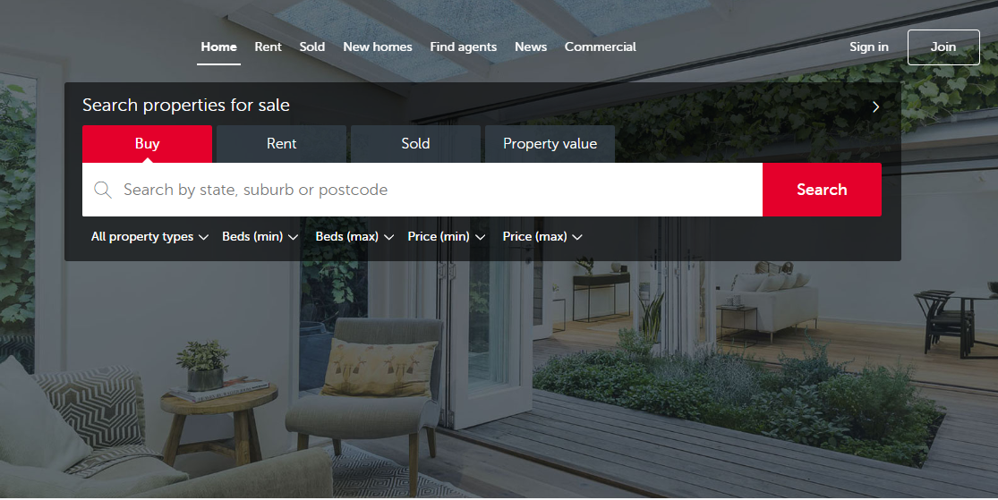**

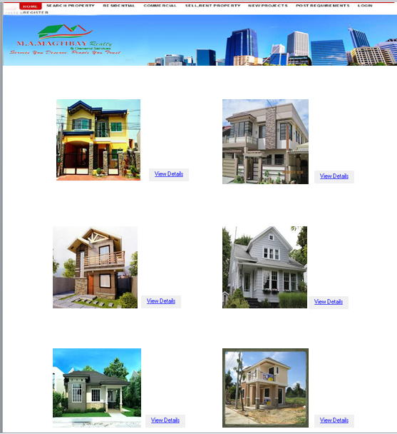

****

**BIBLIOGRAPHY**

Wana G. (2016) *Real Estate Management System.* Retrieved from<http://www.oocities.org/wanaug/REMIS.pdf>

Rohit, K.G. (2011) *MOBILE REAL ESTATE AGENT FOR ANDROID*

Retrieved from <https://sdsu-dspace.calstate.edu/bitstream/handle/10211.10/1712/Gupta_Rohit.pdf?sequence=1>

Zhou, Y., He, G. (2018) *The research of multidimensional analysis based on multi-source heterogeneous real estate data*. Retrieved from <https://ieeexplore.ieee.org/document/8386528/?part=1>

Xuexiang L., Fulin B., Yongge S. (2012) *System Integration of Digital Real Estate-Management Based on Service is an architecture design real estate management based on service.* Retrieved from <https://core.ac.uk/download/pdf/82029711.pdf>

[Jojo B.](http://jinisyssoftware.com/author/jbalagosa/" \t "_blank) (2017) *Real Estate Management System in the Philippines*. Retrieved from <http://jinisyssoftware.com/real-estate-management-system-software-philippines/>

Konstantinos M. (2016) *Records Management and Electronic Records Management.* Retrieved from <https://www.diva-portal.org/smash/get/diva2:842828/FULLTEXT01.pdf>

Benjamin R.L. (2014) *Management information systems: an information portal for a major with limitless interpretations.* Retrieved from <https://scholarworks.uni.edu/cgi/viewcontent.cgi?article=1125&context=hpt>

Karen C.A. (2012) *Property Management Systems in this document address requirements for property management systems.* Retrieved from <http://www.pps.noaa.gov/personal_property_policies_procedures/jfmip-property-management-system-requirements.pdf>

Anna R. (2012) *Methods of Product and Service Promotion in Social Network Websites Demonstrated.* Retrieved from <https://skemman.is/bitstream/1946/11416/1/anna_rozenblit_BS.pdf>

Marina V. (2012) *Real Property Processes.* Retrieved from<https://www.diva-portal.org/smash/get/diva2:528268/FULLTEXT02.pdf>